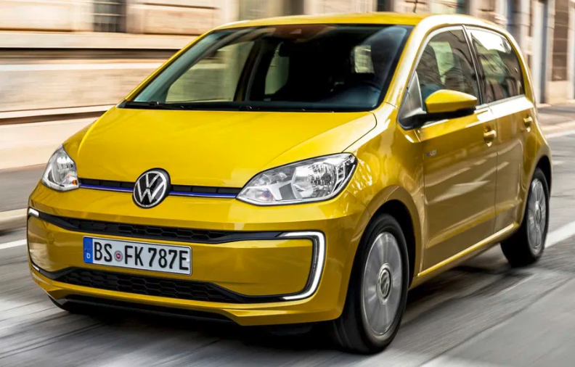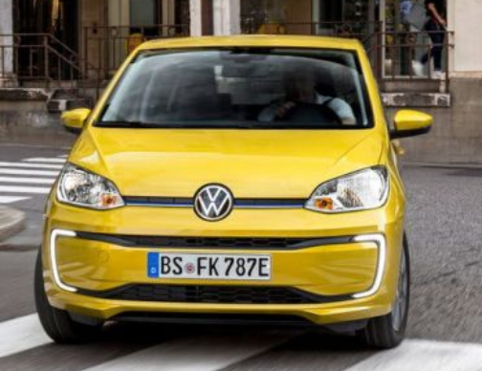

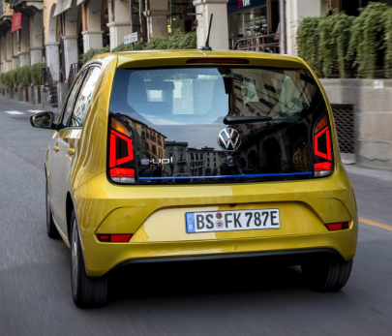

**Main Specifications** for the **2025 Volkswagen Up!**

### 🔧 Powertrain & Performance

* **Engine:** 1.0 L naturally aspirated 3-cylinder MPI
  + Available in:
    - **60 PS** (~44 kW) & **95 Nm**, 0–100 km/h ~14.4 s, top speed 160 km/h
    - **75 PS** (~55 kW) & **95 Nm**, 0–100 km/h ~13.2 s, top speed 171 km/h
* **Transmission:** 5-speed manual (standard), optional ASG automatic (BlueMotion ~Eco)
* **Drive:** Front-wheel drive

**⛽ Fuel Efficiency & Emissions**

* **Combined fuel consumption:** ~4.5–4.7 L/100 km (≈40–50 mpg combined WLTP)
* **CO₂ emissions:** ~96–108 g/km depending on variant

**📏 Dimensions & Weight**

* **Length:** 3,600 mm
* **Width (without mirrors):** ~1,645 mm; with mirrors ~1,910 mm
* **Height:** ~1,504 mm
* **Wheelbase:** 2,407–2,417 mm
* **Kerb weight:** ~905–929 kg (depending on trim)
* **Boot volume:** 251 L (rear seats up)

**🏁 Performance**

* **0–100 km/h:** ~14.4 s (60 PS), ~13.2 s (75 PS)
* **Top speed:** Approximately 160–171 km/h (depending on power output)

**🛋 Interior & Features**

* **Seating:** 4 passengers (5-seat variants available in some trims)
* **Infotainment:** Simple 5″ touchscreen audio system with smartphone integration; higher trims offer upgrade packs
* **Other features:** Electric power steering, manual air conditioning, optional rain/light sensors (higher trims)

**🛡 Safety & Driver-Assistance**

* **Standard:** ABS, ESC, dual front airbags, ISOFIX mounting points
* **Optional:** Autonomous emergency braking, front/rear parking sensors, fatigue detection, hill-hold (in BlueMotion)
* **Emissions/Efficiency Rating:** Meets Euro 6 standards; BlueMotion trims achieve about 96 g/km CO₂

**🚗 Chassis & Wheels**

* **Suspension:** Front MacPherson strut; rear torsion beam
* **Wheels:** 14″ steel standard; 15″ alloys on higher trims
* **Turning circle:** ~9.8 m kerb-to-kerb

**✅ Quick Specs Summary**

| **Feature** | **Detail** |
| --- | --- |
| **Engine** | 1.0 L MPI (60 PS or 75 PS) |
| **Transmission** | 5MT standard, 5‑speed ASG optional |
| **Fuel Consumption** | ~4.5–4.7 L/100 km combined |
| **CO₂ Emissions** | ~96–108 g/km |
| **Dimensions (L×W×H)** | 3,600 × 1,645/1,910 × 1,504 mm |
| **Wheelbase** | ~2,410 mm |
| **Weight** | ~905–929 kg |
| **Boot Space** | 251 L |
| **Performance** | 0–100 km/h in 13–14 s; top speed ~160–171 km/h |
| **Safety** | ABS, ESC, airbags, optional AEB & sensors |
| **Notable** | BlueMotion variant with 4.2 L/100 km and auto wipers/sensors |